Create 2 radio buttons with link and file,
If I enter the invalid link alert message is displaying
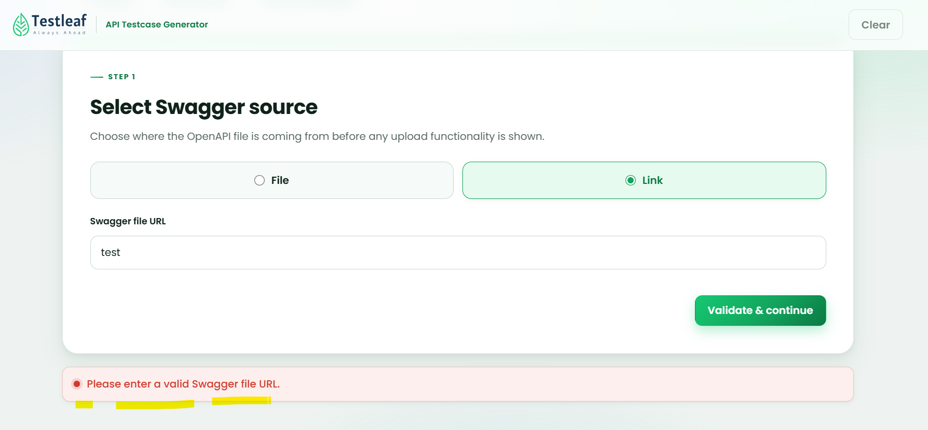
Once enter the proper link –
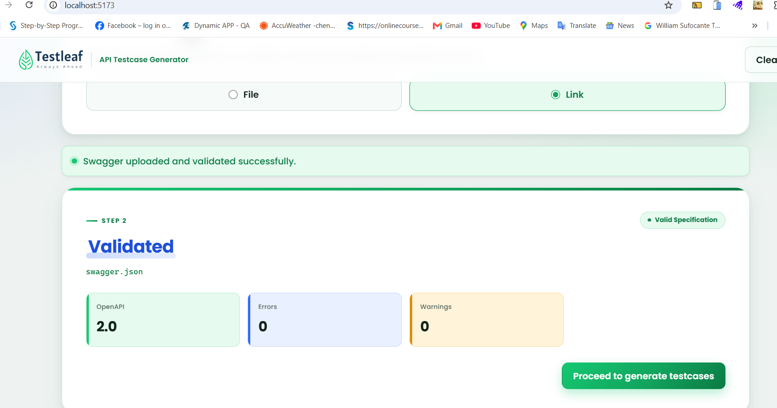
Proceed to generate testcases button- testcases has been generated
